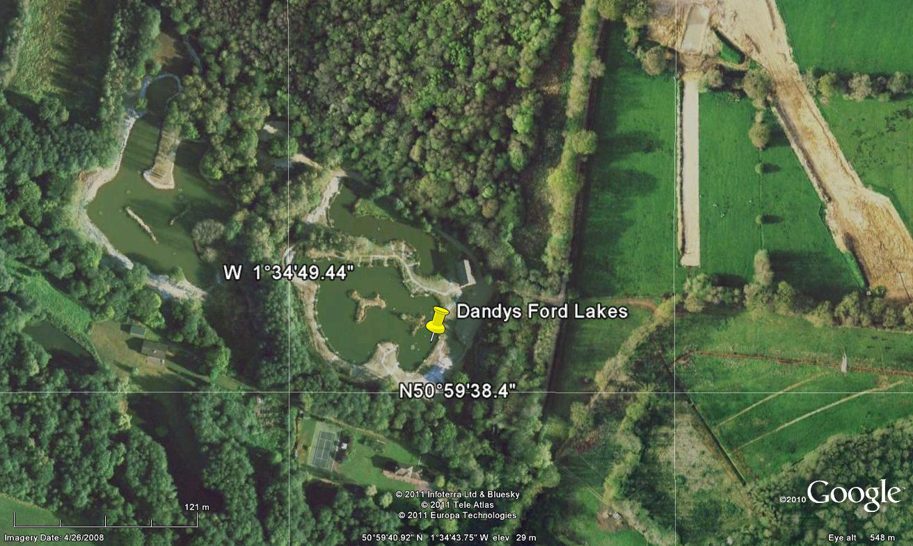
Aerial view of Dandy’s Ford Lakes giving you the GPS co-ordinates to help you find us.

